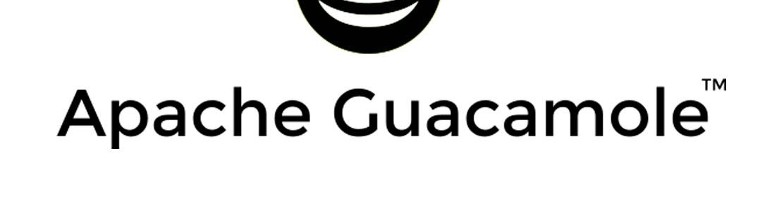
- What is Apache Guacamole?
- Apache Guacamole is a clientless remote desktop gateway. It supports standard protocols like VNC, RDP, and SSH.

- How do we install Apache Guaca?
- We have created an EC2 instance - used Ubuntu (AMI)
- You get a Public IP address - add that in PuTTY

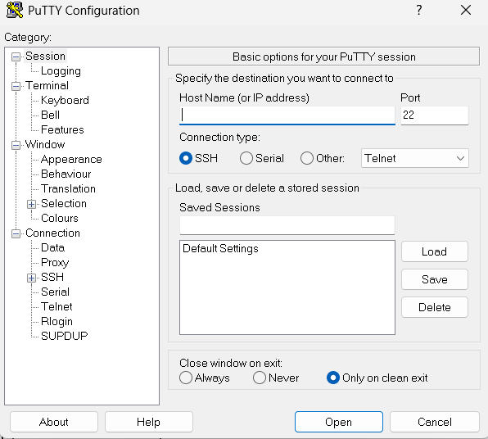

- In left - Click SSH — Auth — Credentials
- Add the .ppk file

- You will be redirected to the Command line
- Install Cloudron.io

- YouTube for Reference: access EVERYTHING from your web browser!! (Linux and Windows Desktop, SSH) // Guacamole Install

- What is Cloudron.io? Cloudron is a platform that makes it easy to deploy, manage, and secure web apps on our own server.
- Login Credentials: hari chandana

- We have installed Guaca from their web apps (App Store)

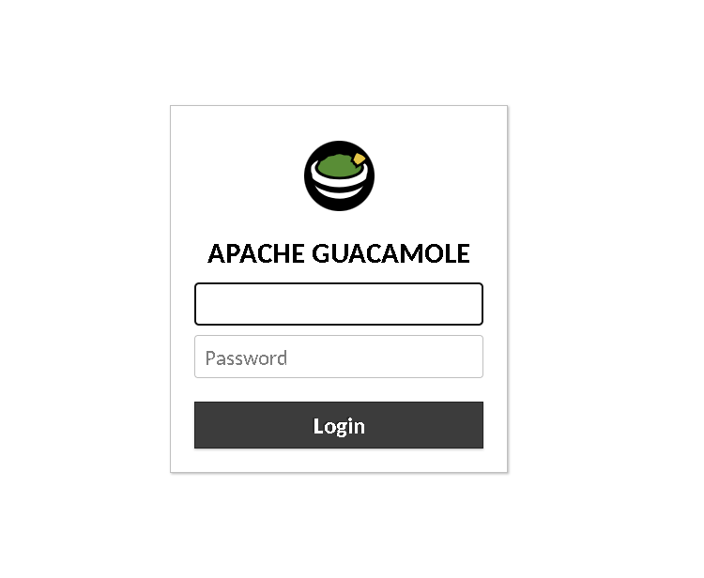
Url: remote.karpavai.cloud4green.com
Temp Credentials: Username - guacadmin
Password - guacadmin

- Steps to add an RDP - Windows

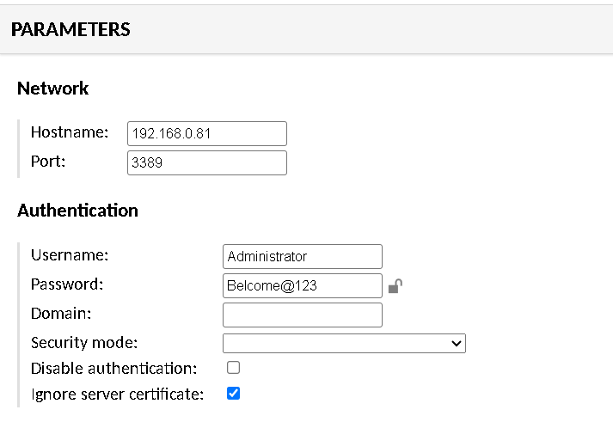

Note: Hostname: Private IP Address (EC2)

- Steps to add an RDP - Linux

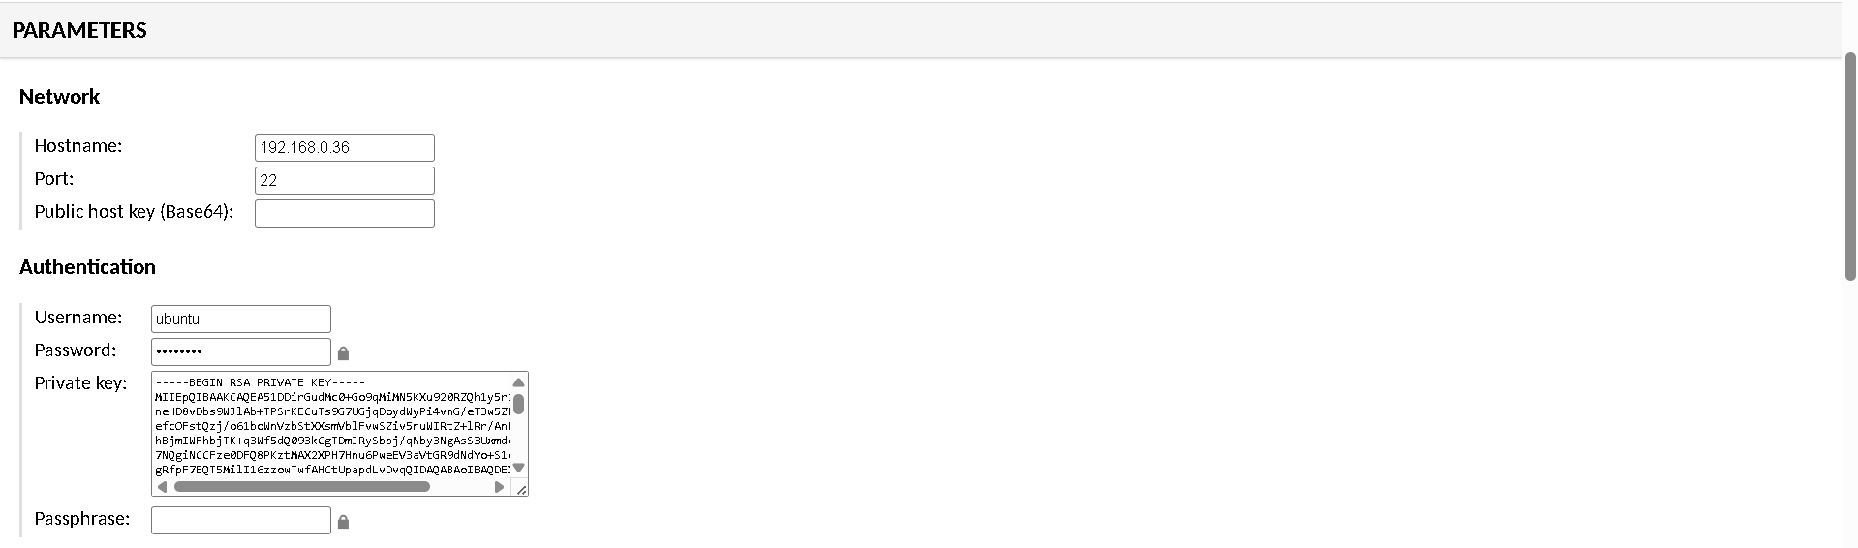

Note: IMP (add a Private key)
Should start from - - - BEGIN RSA PRIVATE KEY - - - -

